COMPUTER FUNDAMENTAL LAB REOPRT # 2

- Objectives
The primary goal of this session was to establish a fundamental understanding of C++ syntax Key learning outcomes included:
- Implementing the basic boilerplate structure of a C++ program.
- Managing Standard I/O (Input/Output) using cin and cout.
- Applying appropriate Data Types and Arithmetic Operators.
- Practicing industry-standard indentation and documentation (comments).

2. Technical Summary
A. Basic Syntax & I/O
Every functional C++ program requires the #include <iostream> header and a main() function.
- cout <<: Used for displaying data.
- cin >>: Used for capturing user input.
- endl: A manipulator used to insert a new line.
B. Data Types
C++ requires explicit declaration of variables. The following were utilized:
- int: For whole numbers.
- double: For high-precision decimal values.
- char: For single characters (using single quotes).
- bool: For logical True/False.
- string: For text sequences.
C. Arithmetic Operators
Calculations are performed using:
- Addition (+), Subtraction (-), Multiplication (*).
- Division (/): Note that integer division truncates decimals.
- Modulus (%): Returns the remainder of a division.

EXAMPLE # 1
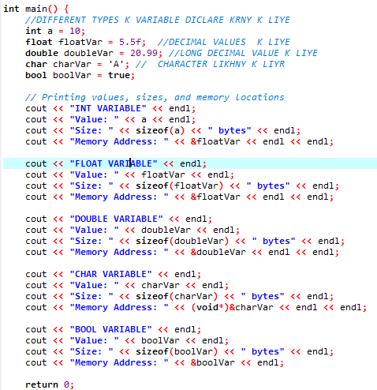
EXAMPLE # 2
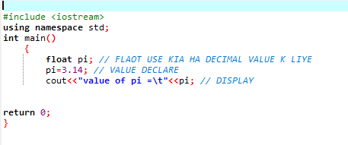
EXAMPLE # 3
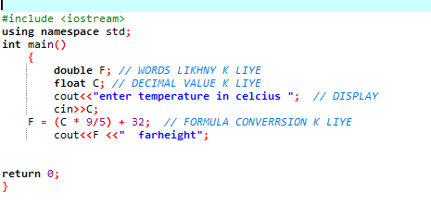
END

